Catalog
1.How to use 2
2. General Setting 5
3. Bard Setting 8
4. Overlay 9

1.How to use
You can't use Magitek at the same time! The original version is buggy, I've provided the author with a pr (https://github.com/Exmortem/MagitekRoutine/pull/339), but it hasn't merged after many days.
If you must use Magitek at the same time, please refer to my submission to modify the source code of Magitek.
This CombatRoutine currently supports only Bard, Reaper, and there are no plans to support other jobs.
All PVE dungeons can be used, including raids, with bis, can easily reach logs90+, if you can plan the use of skills according to Dungeon's timeline, and then accompanied by some luck, you can challenge the Logs99.
I have now provided an easy-to-use trigger tool, with the help of which you can plan your skills according to Dungeon's timeline or various events and automate them after editing! Please see the Trigger Tutorial section of this document for more details.
LegacyType of movement settings is highly recommended
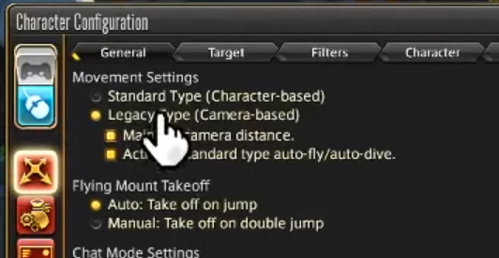

Now, let's start the tutorial!
First, place the unpacked AEAssist into the Routines directory in Rebornbuddy
If there is an old version, remember to delete it completely.
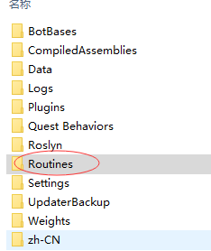

Choosed ATB mode and AEAssist,then click start,you will see the follow overlay:
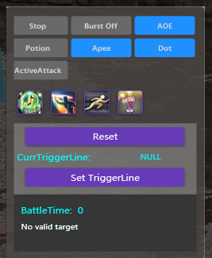
If the current job is bard or reaper:

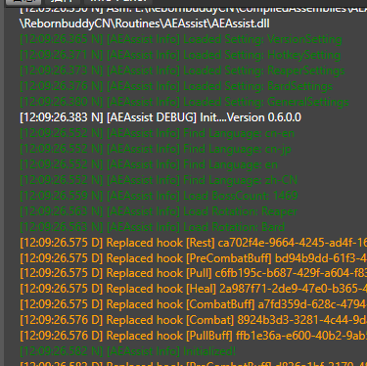
And if not,you can see “Xxx is not supported”

General Setting
When you open the setting window:
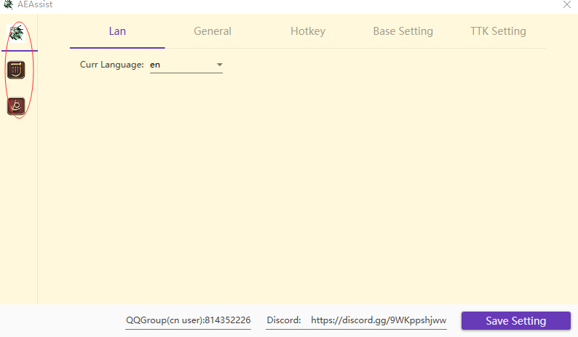
The 3 icons in the red circle in the upper left corner represent:
General Setting
Bard Setting
Reaper Setting

GeneralSetting:
  - Lan: For en users, the only recommended option is en,If you are using a jp or other language client, please contact me for more support
- General:
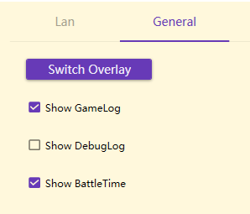

Switch Overlay: Show or hide overlay
Show Gamelog: When checked, routine will print skill usage/character lines and such in rb's log
Show Debuglog: Don't check it unless necessary. This is used to Debug
Show BattleTime: Displays the time elapsed since the start of the battle instead of the local time
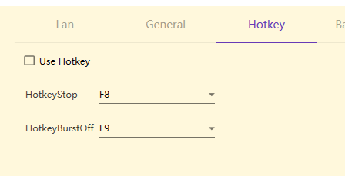
Hotkey control for stop and burst off.
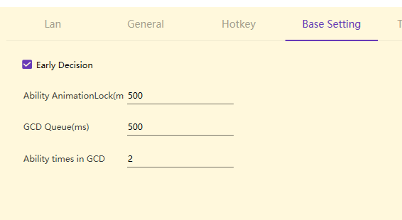

Early Decision: Whether to advance 500ms to decide the next GCD spell. Recommend bard check, reaper please try more differences before deciding
Ability AnimationLock:Estimate the animation duration of each Ability spell, if your latency is high, you can adjust it to 0, at the cost of a slight increase in cpu consumption.
GCD Queue: It is not recommended to modify it!!!
Ability times in GCD: If your latency is high, change it to 1

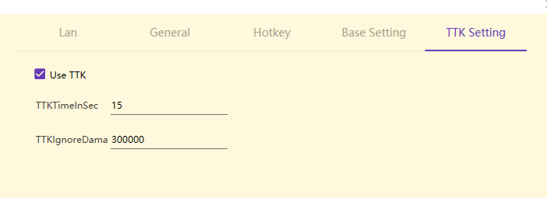
Time to kill.
Sometimes your enemy is about to die, and you don't want to continue using Dot or Burst on it.
TTKTimeInSec: How many seconds for the enemy to die
TTKIgnoreDamage: Some very large damage is not counted in the TTK calculation.

Don't forget to click SaveSetting, when you make some changes.

Bard Setting
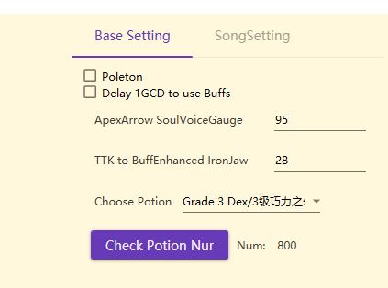

Delay 1GCD to use buffs: By default, the use of battle voice will be delayed by one GCD compared to RagingStrikes.With this option checked, it will delay by 2 GCDs.

ChoosePotion,CheckPotion Num: Which Potion do you want to use?

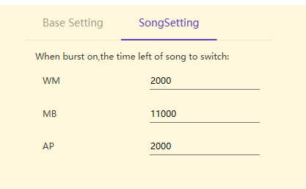
If the current state is burst off, then each song will last 45 seconds before switching to the next one. The default switching order is WM->MB->AP

Overlay
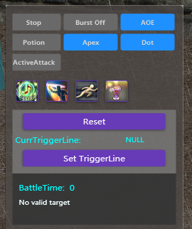

Stop: Clear the selection of the current target and stop the action.
Burst off: for bard, barrage,battle voice,radiant final and ragingstrikes will not be used
Reset: All Toggles are reset to their default state except Potion.
ActiveAttak: By default, the target will only be attacked when the countdown is complete, or if the target is attracted to any unit. When this option is checked, your character will actively attack the current target.
Set TriggerLine: This will be covered in the next release, please wait for the tutorial.

